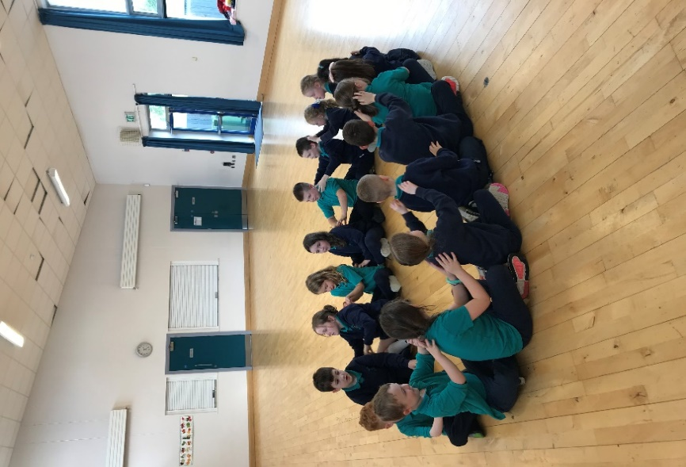
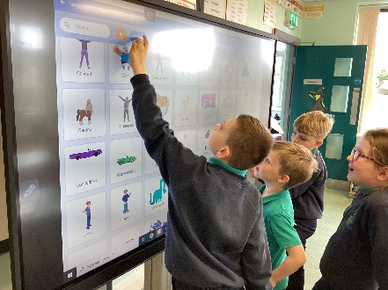

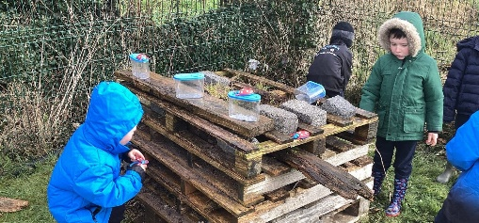
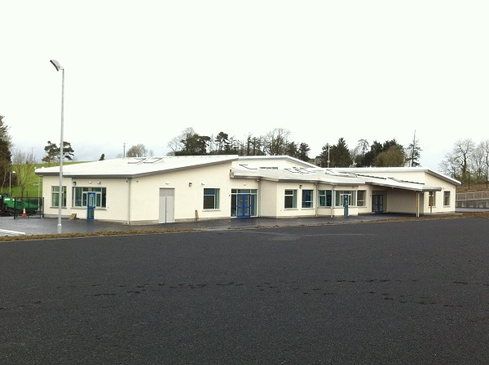
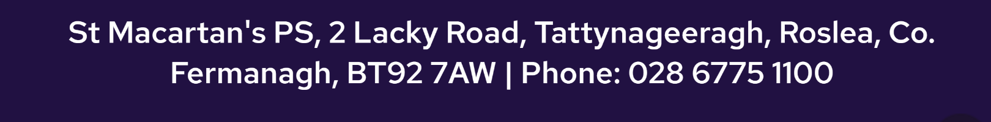
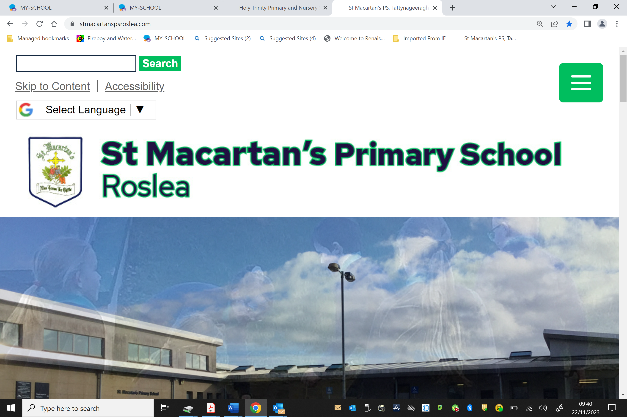
Please feel free to contact the school office if this date/time does not suit.

- 1:17 teacher - pupil ratio – personalised pathways for every child.
- On average, 98% of our pupils achieve at or above expected levels in literacy and numeracy – well above the Northern Ireland average of 77%.
- Modern, spacious, and fully accessible facilities.
- Dedicated and experienced staff with high standards for teaching and learning.
- Play and Stay afterschool facility.
- A wide range of sports and afterschool clubs.

For more information visit our school website:
www.stmacartanspsroslea.com

2026 P1 Admission
Is your child starting school in September 2026?
Come along with your child to meet our friendly staff and pupils, explore our wonderful facilities, and gain an insight into the rich educational experiences we offer.
At our school, children are at the heart of everything we do, and we pride ourselves on being a family-like, caring community where every child feels valued and supported.

Wednesday 10th of December 2025
Tour of our school 9:30am – 10:30am
Refreshments will be served.

OPEN DAY

